**Connecting BN-220 GPS to Raspberry Pi**

1. Wire BN-220 GPS module to Raspbery Pi as shown in *Figure 1.*
2. Ensure Paspberry Pi is up to date by running the following commands.
   * sudo apt-get update
   * sudo apt-get upgrade
3. Run the raspi-config tool.
   * sudo raspi-config
4. Use the **arrow keys** to go down and select “**5 Interfacing Options**“. Once this option has been selected, you can press **Enter**.
5. With the next screen you will want to use the **arrow keys** again to select “**P6 Serial**“, press **Enter** once highlighted to select this option.
6. You will now be prompted as to whether you want the **login shell to be accessible over serial**, select **No** with your **arrow keys** and press **Enter** to proceed.
7. Immediately after you will be asked if you want to make use of the **Serial Port Hardware**, make sure that you select **Yes** with your **arrow keys** and press **Enter** to proceed.
8. You should see the following text appear on your screen.

**The serial login shell is disabled  
The serial interface is enabled**

1. Before these changes fully take effect, we must first restart the Raspberry Pi. To do this first get back to the terminal by pressing **Enter** and then **ESC**.
2. Type the following command into the terminal on the Raspberry Pi to restart it.
   * sudo reboot
3. Check to make sure that everything has been changed correctly by running the following command on your Raspberry Pi.
   * dmesg | grep tty
4. Make sure the following message **is not displayed in the output.** These messages indicate that Serial Login is still enabled for that interface.

[ttyS0] enabled

1. You’re all set for serial communications on the GPIO pins!
2. Run the following commands to test the hardware.
   * cd <git-repo-path>/GNSS\ Module/
   * python2 gpsSerialRead.py

Other Notes:

* Blue blinking LED indicates messages being sent over the TX wire
* Red static LED indicated GPS lock

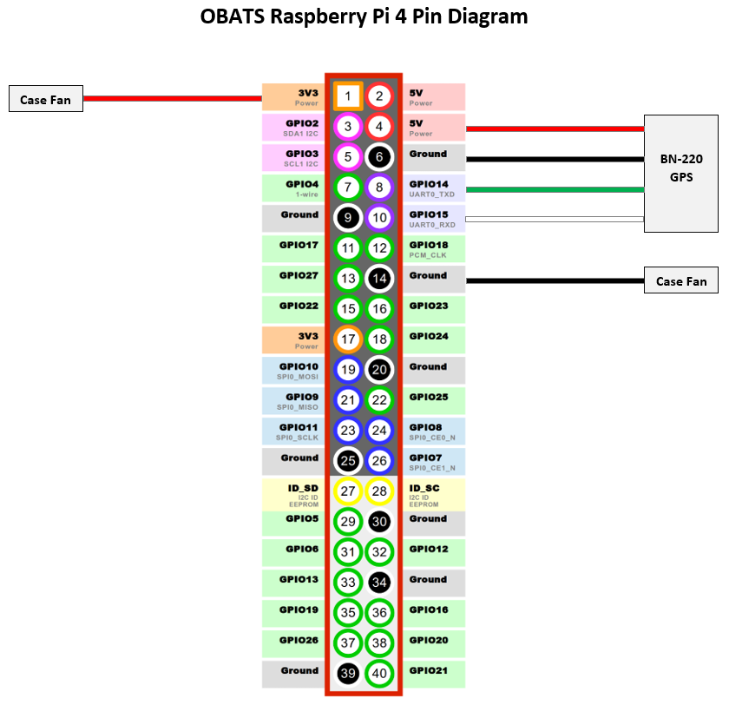  
Figure 1: Raspberry Pi – GPS wiring diagram